**Determining Whether Graphs of Lines are Parallel or Perpendicular**

Parallel lines have the same slope and different $y-$ intercepts. Lines that are parallel to each other will never intersect.

Perpendicular lines intersect at a 90-degree angle. The slope of one line is the negative reciprocal of the other.

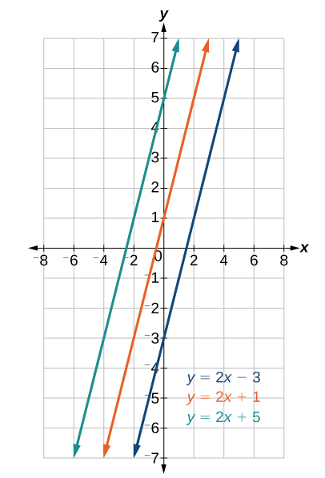 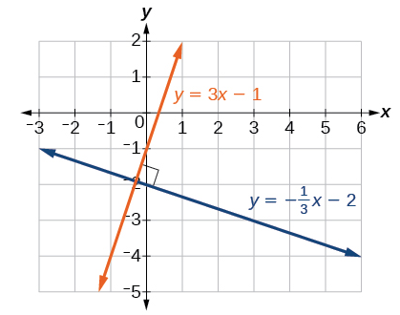

Examples:

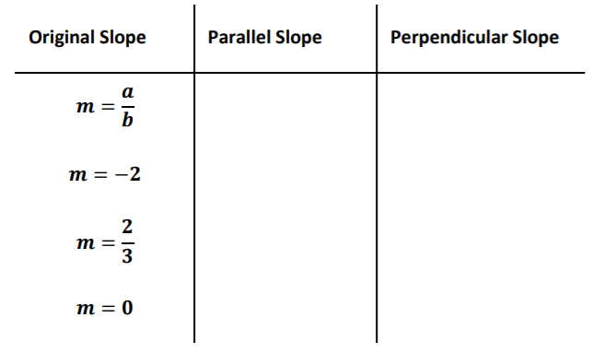

1. Given the functions below, identify the functions whose graphs are a pair of parallel lines and a pair of perpendicular lines

$$f\left(x\right)=2x+3$$

$$g\left(x\right)=\frac{1}{2}x-4$$

$$h\left(x\right)=-2x+2$$

$$j\left(x\right)=2x-6$$

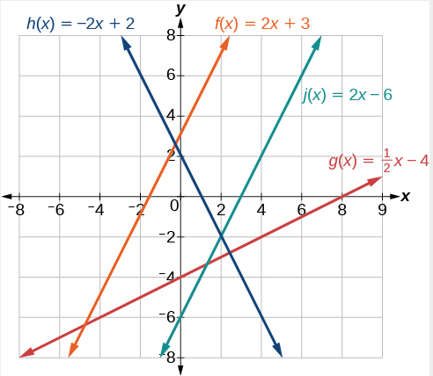

1. Determine whether the lines are parallel, perpendicular, or neither: $2y-x=10$ and $2y=x+4$.

Determining whether two lines are parallel or perpendicular is a matter of comparing the slopes. To write the equation of a line parallel or perpendicular to another line, follow the same principles as finding the equation of a line paying attention to the necessary slope.

**Writing the Equation of Lines Parallel or Perpendicular to a Given Line**

Examples

1. Write the equation of a line parallel and perpendicular to $5x+3y=1$ and passing through the point (3, 5).
2. A line passes through the points $(-2, -15)$ and $(2, -3)$. Find the equation of a perpendicular line that passes through the point $(6, 4)$.
3. Write an equation for the line that is parallel to $h\left(x\right)=\frac{1}{2}x+1$ and passes through the point $(-3, 1)$.